DevOps Automation Assessment Report
Application: Oracle Customer to Meter
Source Control: Azure DevOps
Infrastructure: Oracle Cloud Infrastructure
Prepared By: [Your Name]
Date: [Insert Date]

1. Executive Summary
The Oracle C2M deployment process is currently manual and operationally high-risk. Three types of deployments exist: JAVA, CMA, and SQL database changes.
Currently:
- Only applyCM.sh is reliably used for building EARs.
- Existing deployment scripts are outdated.
- WebLogic restart scripts do not include redeployment.
- CMA deployment scripts exist but require modification.
- SQL deployments are fully manual and lack version control or rollback.
Automation is technically feasible. A phased approach will reduce operational risk, improve consistency, and enable faster deployments while leveraging existing infrastructure.
Recommended Phases:
- Script modernization and parameterization
- CI/CD pipeline implementation using Azure DevOps
- Governance, rollback, and approval workflow integration

2. Current State Assessment (CS)

2.1 Application Overview
The Oracle C2M application supports utility billing operations and includes:
- Application Server: WebLogic on OCI VM
- Java Customizations: Stored under /u01/ouaf/<ENV>/java
- CMA Configurations: Managed via Oracle-specific CMA tool
- SQL Scripts: Database modifications executed manually by DBAs
- Batch Jobs: Includes F1-FLUSH post CMA deployment
- Source Control: Azure DevOps repository
Observations:
- No consistent automation exists for deployment or testing
- High dependency on manual intervention increases risk of errors
- No structured logging or audit trail exists

2.1.1 Environment Topology
Environments are configured as follows:
DEV / SIT:
- Single-node application server
- Deployment is straight forward as all components reside on one server
UAT / PPE / PROD:
- Two-node application servers (Clustered WebLogic setup)
- Nodes are independent and do NOT share a common filesystem
- Each node maintains its own local deployment directories
Key Observation:
- In multi-node environments, deployment artifacts (EAR/WAR) and Java changes must be deployed individually on both nodes.
- Lack of shared storage increases deployment complexity and risk of inconsistency between nodes.

2.2 Deployment Types & Status
Deployment Type | Current Process | Observations | Automation Maturity
JAVA | Manual code copy → applyCM.sh → manual EAR deployment → manual WebLogic restart | Redeployment and health validation not automated; no rollback | Low
CMA | Legacy script → manual F1-FLUSH batch | Script outdated; batch execution manual; no validation | Low-Medium
SQL | Manual DBA execution | No versioning, no pipeline integration, no rollback | Very Low
Key Pain Points:
- Manual steps increase error probability
- Deployment is slow and inconsistent across environments
- Lack of rollback and health verification mechanisms
- Batch job monitoring is manual, prone to failure
Multi-node deployment challenge in UAT/PPE/PROD
- Application servers do not share disk storage
- Manual deployment must be repeated on each node
- High risk of version mismatch between nodes
- Increased deployment time and operational overhead

3. Technical Feasibility Study (TF)

3.1 Repository & Code Readiness
- Java code version controlled in Azure DevOps
- Folder structure follows environment conventions (/java, /config, etc.)
- Existing CI/CD pipelines are not configured
Feasibility: High
Considerations:
- Branching strategy may need refinement for automated deployments
- Proper tagging of release versions required

3.2 Build Automation Feasibility (JAVA)
- applyCM.sh builds the EAR file on the application server
- Currently, it is server-dependent
- Required Enhancements:
  - Accept CMA name and environment parameters
  - Provide proper exit codes for success/failure
  - Write standardized logs for pipeline consumption
  - Ensure non-interactive execution
Multi-node Consideration:
In UAT/PPE/PROD environments:
- EAR deployment must be executed on both application nodes
- applyCM.sh execution may need to run on one node, but deployment must propagate to both nodes
Automation must ensure:
- Either centralized build + distribution
- Or parallel execution on both nodes

- Failure to deploy on both nodes will result in inconsistent application behavior.
Feasibility: High
Effort: Low–Medium

3.3 EAR Redeployment Automation
Current Status: Manual
Required Automation:
- Backup current EAR file
- Redeploy EAR via WLST script or WebLogic REST API
- Validate deployment success
- Apply health checks (port, service availability, logs)
Multi-node Deployment Requirement:
For clustered environments (UAT/PPE/PROD):
- EAR must be deployed to all managed servers across nodes
Deployment approach options:
- 1. WLST-based centralized deployment to cluster (preferred)
- 2. Node-wise deployment via SSH (fallback if WLST not feasible)
Automation must ensure:
- Deployment consistency across both nodes
- Verification of deployment status on each node
- Partial deployment detection and failure handling
Feasibility: High
Effort: Medium

3.4 WebLogic Restart Automation
- Current restart script does not include redeployment
- Automation should include:
  - Controlled shutdown of Admin and Managed Servers
  - Deploy EAR
  - Controlled start of servers
  - Health verification
  - Logging and error reporting
Feasibility: High
Effort: Medium

3.5 CMA Deployment Automation
- Legacy CMA deployment script exists but outdated
- Automation requirements:
  - Parameterize CMA name and environment
  - Execute F1-FLUSH batch automatically
  - Monitor batch completion and success/failure
  - Log all activity
  - Proper exit codes to allow pipeline integration
Feasibility: High
Effort: Medium

3.6 SQL Deployment Automation
- SQL scripts currently executed manually
- Automation requirements:
  - Store SQL scripts in version-controlled repository
  - Execute via SQL*Plus or automated tool
  - Log execution results
  - Fail pipeline on error
  - Implement optional rollback script for failed execution
Feasibility: High
Effort: Medium

3.7 Infrastructure & Tool Feasibility
- OCI VMs accessible via SSH
- Azure DevOps capable of orchestrating deployment pipelines
- OCI DevOps can be considered if Oracle-native governance is required
- Security considerations:
  - Use service accounts for deployment
  - Store credentials securely in pipeline
  - Implement approval gates for PROD
  - Maintain audit logs
Feasibility: High

4. Resource & Skill Readiness (RS)
Role | Required Skills | Current Status
DevOps Engineer | Shell scripting, CI/CD pipeline | Limited
WebLogic Admin | WLST scripting, server restart | Moderate
DBA | SQL automation, version control | Limited
C2M SME | Batch job knowledge (F1-FLUSH) | Strong
Gap Analysis:
- CI/CD pipeline creation and scripting knowledge needs improvement
- Redeployment and rollback scripting not implemented
- SQL deployment standardization required
Estimated effort for full automation readiness: 4–6 weeks

5. Proposed Target State

5.1 JAVA Deployment Flow
- Trigger pipeline on code commit
- Build EAR using applyCM.sh
- If Single Node (DEV/SIT):
- Deploy EAR to the single server
- If Multi Node (UAT/PPE/PROD):
- Deploy EAR to all nodes in the cluster:
- Option 1: WLST deployment to cluster (recommended)
- Option 2: Parallel deployment via SSH to each node
- Restart WebLogic managed servers (cluster-wide)
- Run health checks:
- Validate each node individually
- Validate load-balanced endpoint
- Ensure version consistency across nodes

5.2 CMA Deployment Flow
- Execute refactored CMA deployment script
- Trigger F1-FLUSH batch automatically
- Monitor batch completion and validate results
- Capture logs
- No WebLogic restart required

5.3 SQL Deployment Flow
- Identify release-specific SQL scripts
- Execute via SQL*Plus using pipeline task
- Capture execution output and errors
- Fail pipeline on error
- Tag SQL version for traceability

6. Risks & Mitigation
Risk | Impact | Mitigation
EAR deployment failure | High | Pre-deployment backup & rollback
WebLogic restart failure | High | Health checks & controlled restart
Batch job failure | High | Automated batch monitoring
SQL execution errors | High | Pipeline fail on error & approval gates
Lack of rollback | High | Maintain previous stable artifacts
Partial deployment in
multi-node environments High Fail pipeline if any node deployment fails

7. Recommendations
Phased Implementation:
Phase 1 – Script Modernization:
- Refactor JAVA, CMA, and SQL scripts for parameterization
- Standardize logging and exit codes
Phase 2 – CI/CD Pipeline Implementation:
- Azure DevOps pipeline to orchestrate JAVA, CMA, and SQL deployments
- Integrate SSH deployment tasks for OCI VMs
- Automate batch job execution and monitoring
Phase 3 – Governance & Rollback:
- Implement approval gates for PROD
- Include rollback mechanisms for EAR, CMA, and SQL deployments
- Enable logging, monitoring, and versioning for audit compliance
Future Consideration:
- OCI DevOps migration if Oracle-native governance is required
Standardize multi-node deployment strategy:
- Prefer WebLogic cluster-based deployment using WLST
- Avoid node-specific manual deployments
- Implement parallel deployment validation across all nodes
- Consider shared storage or artifact repository if feasible

8. Source Control (Git Repository Details)
Source Control Platform: Azure DevOps
Repository URL:
https://dev.azure.com/<org>/<project>/_git/<repo>
Branching Strategy:
- feature/*
- release/*
- main/master
Tagging Strategy:
- TAG-based deployment
- All deployments are executed using TAGs created on specific commits
Examples:
- DEV_JAVA_20260407_v1
- UAT_CMA_20260407_v2
- PROD_RELEASE_20260407_v1
Folder Structure:
- /java
- /cma
- /sql
- /scripts
Note:
TAG-based deployment ensures:
- Fixed version deployment
- Easy rollback
- Full traceability across environments

9. Resource Plan & Access Requirement

9.1 Resource Requirement
Role | Responsibility | Count
DevOps Engineer | Pipeline, automation, integration | 1–2
WebLogic Admin | WLST, deployment, restart | 1
DBA | SQL execution & rollback | 1
C2M SME | CMA validation & batch process | 1
Infra Engineer | Server & access setup | 1 (shared)
Total Resources Required: 3–5

9.2 Roles & Responsibilities
DevOps Engineer
- Design Azure DevOps pipelines
- Implement tag-based deployment
- Automate JAVA, CMA, SQL deployments
- Configure email notifications
- Handle logging and error handling
- Develop WLST scripts
- Manage WebLogic restart (Admin + Managed servers)
- Support multi-node deployment
- Execute SQL scripts via automation
- Create rollback scripts
- Validate DB changes
C2M SME
- Validate CMA deployment
- Monitor batch jobs (F1-FLUSH)
- Validate application behavior
Infra Engineer
- Provide server access (SSH)
- Configure OCI/network
- Setup service accounts

9.3 Access Requirement
DevOps Engineer
- Azure DevOps (Repo + Pipeline access)
- SSH access to all environments
- WebLogic Admin Console
- Database access (SQL*Plus)
- Schema-level permissions

C2M SME
- C2M Application Access
- Batch job monitoring
Infra Engineer
- OCI Console access
- VM & network configuration

9.4 Security Recommendations
- Use service accounts (non-personal IDs)
- Store credentials in:
  - Azure DevOps Variable Groups
  - Azure Key Vault
- Enable:
  - Audit logging
  - Approval gates for PROD

10. TO-BE JAVA Deployment Flow (Automation)
Flow:
Developer Commit (Feature Branch)
→ DevOps Creates TAG
→ Azure DevOps Pipeline Trigger (TAG-based)
→ Build Stage (applyCM.sh -b)
→ EAR Artifact Generated
→ Deployment Stage
- DEV/SIT (Single Node):
  - Auto deploy EAR
  - Restart WebLogic
- UAT/PPE/PROD (Multi Node):
  - Deploy via WLST (Cluster) (Preferred)
  - OR Parallel deployment (Node1 + Node2)
  - Restart cluster
→ Automated Validation (URL / Logs / Port Check)
→ SUCCESS / FAILURE
→ Send Email Notification

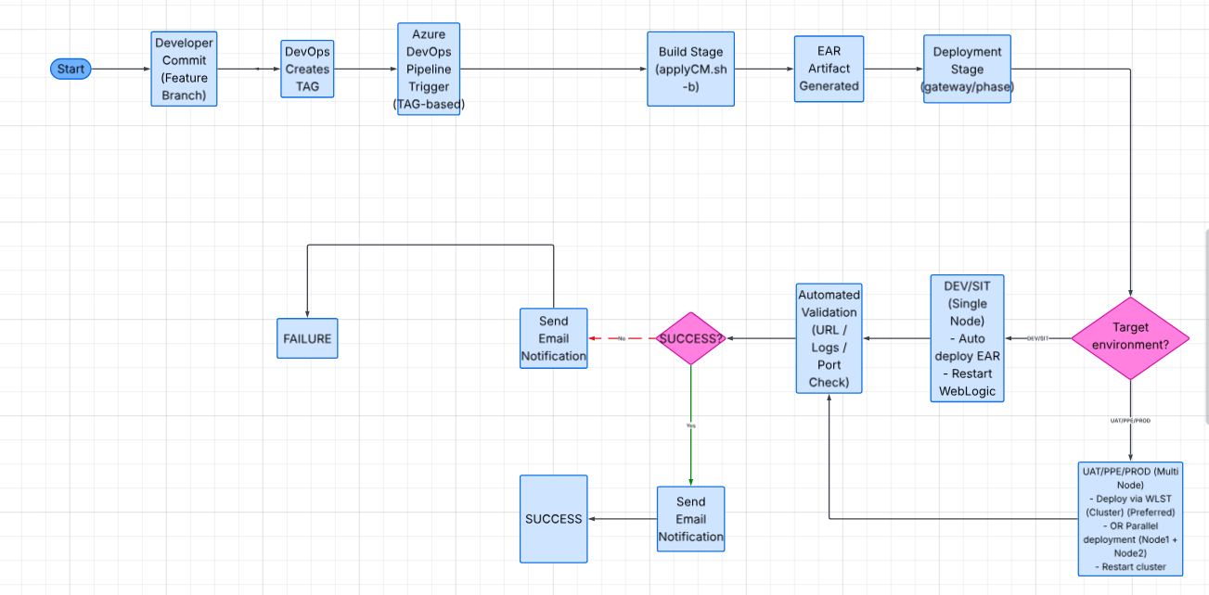

11. TO-BE CMA Deployment Flow (Automation)
Flow:
Developer Commit (CMA File)
→ DevOps Creates TAG
→ Azure DevOps Pipeline Trigger
→ Fetch CMA File (from TAG)
→ Transfer to Server
(Path: SPLOUTPUT/F1_CMA_Files/import)
→ Start TPW (NOL2 Cache)
→ Execute CMA Deployment (Batch Jobs)
→ Monitor Batch Execution
→ Stop TPW
→ Execute flushall.jsp
→ Validation (Batch + Logs)
→ SUCCESS / FAILURE
→ Send Email Notification
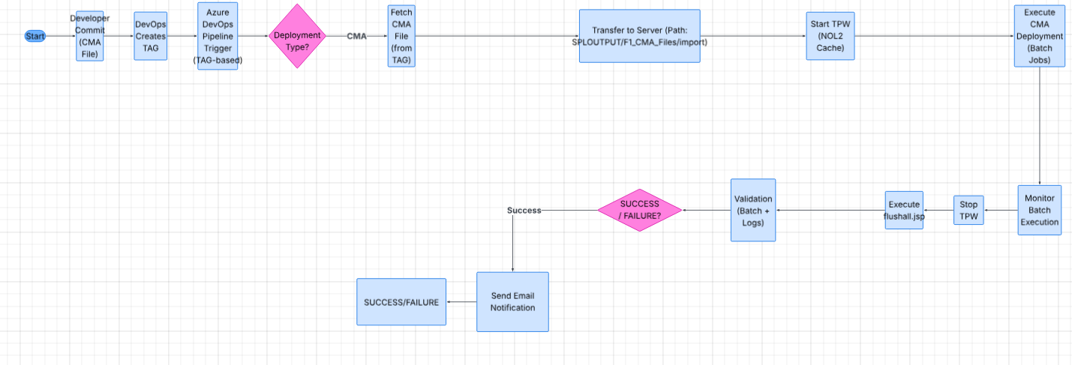

12. TO-BE SQL Deployment Flow (Automation)
Flow:
Developer Commit (SQL Script)
→ DevOps Creates TAG
→ Azure DevOps Pipeline Trigger
→ Identify SQL Scripts (from TAG)
→ Execute SQL via SQL*Plus
→ Capture Logs & Output
→ Automated Validation (Error Check)
→ SUCCESS / FAILURE
→ Send Email Notification
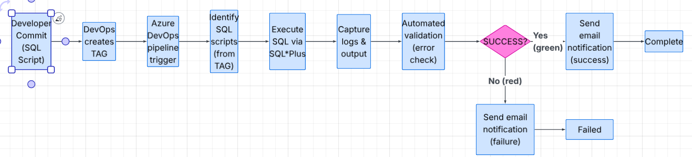

13. Notification Mechanism
After each deployment:
- Email is triggered automatically
Email includes:
- Environment (DEV/SIT/UAT/PPE/PROD)
- TAG Name
- Deployment Type (JAVA/CMA/SQL)
- Status (SUCCESS / FAILED)
- Build ID
- Logs / Pipeline URL
Recipients:
- Developer
- QA Team
- DevOps Team
- Stakeholders

- Next Steps
- Develop WLST script for EAR redeployment
- Refactor CMA script and automate F1-FLUSH batch
- Version SQL scripts and integrate into pipeline
- Create Azure DevOps pipelines with SSH deployment tasks
- Implement health check and rollback mechanisms
- Train DevOps, DBA, and WebLogic teams on automated deployment

15. Summary
The proposed TO-BE model introduces:
- Fully automated deployment using Azure DevOps pipelines
- TAG-based controlled deployment strategy
- Support for both single-node and multi-node environments
- Automated validation and health checks
- Email notification for deployment status
- Reduced manual effort and operational risk

